НАЦІОНАЛЬНИЙ ТЕХНІЧНИЙ УНІВЕРСИТЕТ УКРАЇНИ

«КИЇВСЬКИЙ ПОЛІТЕХНІЧНИЙ ІНСТИТУТ

ІМЕНІ ІГОРЯ СІКОРСЬКОГО»

ФАКУЛЬТЕТ ІНФОРМАТИКИ ТА ОБЧИСЛЮВАЛЬНОЇ ТЕХНІКИ

(повна назва інституту/факультету)

КАФЕДРА інформатики та програмної інженерії

(повна назва кафедри)

## КУРСОВА РОБОТА

з дисципліни «Бази даних»

(назва дисципліни)

на тему: База даних для збереження даних про футбольні чемпіонати

Студента (ки) __2__ курсу _ІТ-01_ групи спеціальності 121 «Інженерія програмного забезпечення»

_____________Нікітченко Н. О. ____________

(прізвище та ініціали)

Керівник _____ Марченко О. І._____________

(посада, вчене звання, науковий ступінь, прізвище та ініціали)

Національна шкала _____________________

Кількість балів: ______ Оцінка ECTS _______

Члени комісії _______________ ___________________________________________

(підпис) (вчене звання, науковий ступінь, прізвище та ініціали)

_______________ ___________________________________________

(підпис) (вчене звання, науковий ступінь, прізвище та ініціали)

_______________ ___________________________________________

(підпис) (вчене звання, науковий ступінь, прізвище та ініціали)

Київ – 2021 рік

**ЗАВДАННЯ**

Завданням курсової роботи є розробка бази даних з забезпеченням роботи всіх бізнес правил та можливість її подальшого використання. При розробці проекту потрібно врахувати певні вимоги:

* вимоги до функціональності (наявність усіх функцій, які необхідні для реалізації поставленої задачі);
* вимоги до цілісності даних;
* вимоги до мінімізації об’єму даних, що зберігаються;
* наявність багатокористувацького режиму; - вимоги до швидкодії.

Це необхідно для створення ефективної та зручної системи зберігання користувацьких даних. Також потрібно чітко враховувати предметну область поставленої цілі для чого варто створити ER – модель, що дозволить краще зрозуміти всі бізнес правила та особливості поставленої задачі. Для її створення необхідно:

* детально проаналізувати предметне середовище;
* сформулювати бізнес-правила, які будуть основою завдання обмежень при проектуванні та реалізації бази даних;
* виявити необхідний набір сутностей;
* визначити необхідний набір атрибутів для кожної сутності;
* визначити зв'язки між об'єктами;
* описати отриману ER-модель в одній з відомих нотацій;
* розробити модель користувачів бази даних з описом їх прав;

Після аналізу предметної області необхідно:

* побудувати реляційну схему з ER-моделі;
* створити базу даних, що була спроектована, у форматі обраної системи управління базою даних (СУБД);
* створити користувачів бази даних, реалізувавши розроблену багатокористувацьку модель;
* імпортувати дані з використанням засобів СУБД в створену базу даних;
* мовою SQL написати запити для визначених на етапі аналізу предметного середовища потреб користувачів;
* оптимізувати роботу запитів (продемонструвати роботу до і після оптимізації).

Обов’язкові вимоги до проєкту:

* кількість таблиць бази даних не менше 10;
* реалізація створених бізнес-правил;
* забезпечення цілісності бази даних;
* використання збережених процедур/функцій;
* використання тригерів;
* використання генераторів;
* використання представлень;
* створення не менше 20 DML-запитів типу SELECT (не включаючи insert, delete, update);
* кількість таблиць, атрибути яких використовуються у запиті не менше двох.

**ЗМІСТ**

ВСТУП

РОЗДІЛИ ОСНОВНОЇ ЧАСТИНИ РОБОТИ

2.1 ОПИС ПРЕДМЕТНОГО СЕРЕДОВИЩА

* 1. КОНЦЕПТУАЛЬНА МОДЕЛЬ БАЗИ ДАНИХ
  2. ЛОГІЧНА МОДЕЛЬ БАЗИ ДАНИХ
  3. ПРОГРАМНА РЕАЛІЗАЦІЯ

2.5.1 Створення бази даних

2.5.2 Наповнення схеми даними

* + 1. Створення запитів
    2. Використання процедури
    3. Використання тригера
    4. Використання представлення
    5. Використання функції

ВИСНОВКИ

СПИСОК ВИКОРИСТАНОЇ ЛІТЕРАТУРИ

ДОДАТКИ

ДОДАТОКА ........................................................................................................... 33

ДОДАТОКБ ............................................................................................................ 38

ДОДАТОКВ ........................................................................................................... 49

ВСТУП

В нашому житті напевне кожна людина бачила футбол в тому чи іншому вигляді. Сучасний спорт нездатний обійтися без його головної частини. Футбольні чемпіонати завжди були цікаві різним людям, тому й важливо розробити базу даних, яка надасть можливість зручно зберігати дані і забезпечить зручний доступ до них.

Перед реалізацією бази даних було необхідно обрати СУБД. Зваживши всі за і проти вибір впав на PostgreSQL за її широкий функціонал і відкриті джерела коду.

РОЗДІЛИ ОСНОВНОЇ ЧАСТИНИ РОБОТИ

2.1 ОПИС ПРЕДМЕТНОГО СЕРЕДОВИЩА

Загалом першим кроком у розробці бази даних є опис предметного середовища обраної теми. Без чіткого аналізу теми неможливо розробити базу даних, яка б задовольнила потреби користувачів. В даному випадку цією темою є збереження даних про футбольні чемпіонати.

Футбольні чемпіонати мають місце проведення. Тому реалізована база даних має містити в собі дані про те, де проводиться чемпіонат. Основою чемпіонатів являються гравці і команди, тож база даних має містити в собі дані і про них. Також в команд є тренери, і матчі в яких є рефері і асистенти рефері. З огляду на ці дані ми маємо реалізувати можливість збереження їх даних в базі даних.

2.2 КОНЦЕПТУАЛЬНА МОДЕЛЬ БАЗИ ДАНИХ

Після аналізу предметної області було необхідно розробити концептуальну модель бази даних.

Було виділено такі сутності:

футбольна країна;

футбольне місто;

футбольний майданчик;

футбольна команда;

ігрове положення;

гравець;

рефері;

матч;

тренер;

помічник арбітра;

деталі матчу;

деталі голу;

серія пенальті;

гравець в грі;

гравець поза грою;

капітан матчу;

тренер команд;

пенальті воротар.

Далі було необхідно визначити атрибути сутностей і їх типи даних. Вказані в порядку наведеному вище сутності є таблицями з атрибутами:

|  |  |  |  |
| --- | --- | --- | --- |
| Таблиця: |  |  |  |
|  | ***football_country*** |  |  |
| Атрибути: |  | Тип даних: |  |
|  | pk_country_id |  | NUMERIC |
|  | country_abbreviation |  | VARCHAR(4) |
|  | country_name |  | VARCHAR(40) |
| Таблиця: |  |  |  |
|  | ***football_city*** |  |  |
| Атрибути: |  | Тип даних: |  |
|  | pk_city_id |  | NUMERIC |
|  | city |  | VARCHAR(25) |
|  | fk_country_id |  | NUMERIC |
| Таблиця: |  |  |  |
|  | ***football_venue*** |  |  |
| Атрибути: |  | Тип даних: |  |
|  | pk_venue_id |  | NUMERIC |
|  | venue_name |  | VARCHAR(30) |
|  | fk_city_id |  | NUMERIC |
|  | audience_capacity |  | NUMERIC |
| Таблиця: |  |  |  |
|  | ***football_team*** |  |  |
| Атрибути: |  | Тип даних: |  |
|  | fk_team_id |  | NUMERIC |
|  | team_group |  | CHARACTER(1) |
|  | match_played |  | NUMERIC |
|  | won |  | NUMERIC |
|  | draw |  | NUMERIC |
|  | lost |  | NUMERIC |
|  | goal_for |  | NUMERIC |
|  | goal_against |  | NUMERIC |
|  | goal_difference |  | NUMERIC |
|  | points |  | NUMERIC |
|  | group_position |  | NUMERIC |
| Таблиця: |  |  |  |
|  | ***playing_position*** |  |  |
| Атрибути: |  | Тип даних: |  |
|  | pk_position_id |  | VARCHAR(2) |
|  | position_description |  | VARCHAR(15) |
| Таблиця: |  |  |  |
|  | ***player_mast*** |  |  |
| Атрибути: |  | Тип даних: |  |
|  | pk_player_id |  | NUMERIC |
|  | fk_team_id |  | NUMERIC |
|  | jersey_number |  | NUMERIC |
|  | player_name |  | VARCHAR(40) |
|  | fk_position_to_play |  | CHARACTER(2) |
|  | date_of_birth |  | DATE |
|  | age |  | NUMERIC |
|  | playing_club |  | VARCHAR(40) |
| Таблиця: |  |  |  |
|  | ***referee_mast*** |  |  |
| Атрибути: |  | Тип даних: |  |
|  | pk_referee_id |  | NUMERIC |
|  | referee_name |  | VARCHAR(40) |
|  | fk_country_id |  | NUMERIC |
| Таблиця: |  |  |  |
|  | ***match_mast*** |  |  |
| Атрибути: |  | Тип даних: |  |
|  | pk_match_number |  | NUMERIC |
|  | play_stage |  | CHARACTER(1) |
|  | play_date |  | DATE |
|  | results |  | CHARACTER(5) |
|  | decided_by |  | CHARACTER(1) |
|  | goal_score |  | CHARACTER(5) |
|  | fk_venue_id |  | NUMERIC |
|  | fk_referee_id |  | NUMERIC |
|  | audence |  | NUMERIC |
|  | fk_player_of_match |  | NUMERIC |
|  | stop1_second |  | NUMERIC |
|  | stop2_second |  | NUMERIC |
| Таблиця: |  |  |  |
|  | ***coach_mast*** |  |  |
| Атрибути: |  | Тип даних: |  |
|  | pk_coach_id |  | NUMERIC |
|  | coach_name |  | VARCHAR(40) |
| Таблиця: |  |  |  |
|  | ***assistant_referee_mast*** |  |  |
| Атрибути: |  | Тип даних: |  |
|  | pk_assistant_referee_id |  | NUMERIC |
|  | assistant_referee_name |  | VARCHAR(40) |
|  | fk_country_id |  | NUMERIC |
| Таблиця: |  |  |  |
|  | ***match_details*** |  |  |
| Атрибути: |  | Тип даних: |  |
|  | fk_match_number |  | NUMERIC |
|  | play_stage |  | VARCHAR(1) |
|  | fk_team_id |  | NUMERIC |
|  | win_lose |  | VARCHAR(1) |
|  | decided_by |  | VARCHAR(1) |
|  | goal_score |  | NUMERIC |
|  | penalty_score |  | NUMERIC |
|  | fk_assistant_referee |  | NUMERIC |
|  | fk_player_goal_keeper |  | NUMERIC |
| Таблиця: |  |  |  |
|  | ***goal_details*** |  |  |
| Атрибути: |  | Тип даних: |  |
|  | pk_goal_id |  | NUMERIC |
|  | fk_match_number |  | NUMERIC |
|  | fk_player_id |  | NUMERIC |
|  | fk_team_id |  | NUMERIC |
|  | goal_time |  | NUMERIC |
|  | goal_type |  | CHARACTER(1) |
|  | play_stage |  | CHARACTER(1) |
|  | goal_schedule |  | CHARACTER(2) |
|  | goal_half |  | NUMERIC |
| Таблиця: |  |  |  |
|  | ***penalty_shootout*** |  |  |
| Атрибути: |  | Тип даних: |  |
|  | pk_kick_id |  | NUMERIC |
|  | fk_match_number |  | NUMERIC |
|  | fk_team_id |  | NUMERIC |
|  | fk_player_id |  | NUMERIC |
|  | score_goal |  | VARCHAR(1) |
|  | kick_number |  | NUMERIC |
| Таблиця: |  |  |  |
|  | ***player_booked*** |  |  |
| Атрибути: |  | Тип даних: |  |
|  | fk_match_number |  | NUMERIC |
|  | fk_team_id |  | NUMERIC |
|  | fk_player_id |  | NUMERIC |
|  | booking_time |  | VARCHAR(40) |
|  | sent_off |  | CHARACTER(1) |
|  | play_schedule |  | CHARACTER(2) |
|  | play_half |  | NUMERIC |
| Таблиця: |  |  |  |
|  | ***player_in_out*** |  |  |
| Атрибути: |  | Тип даних: |  |
|  | fk_match_number |  | NUMERIC |
|  | fk_team_id |  | NUMERIC |
|  | fk_player_id |  | NUMERIC |
|  | in_out |  | CHARACTER(1) |
|  | time_in_out |  | NUMERIC |
|  | play_schedule |  | CHARACTER(2) |
|  | play_half |  | NUMERIC |
| Таблиця: |  |  |  |
|  | ***match_captain*** |  |  |
| Атрибути: |  | Тип даних: |  |
|  | fk_match_number |  | NUMERIC |
|  | fk_team_id |  | NUMERIC |
|  | fk_player_captain |  | NUMERIC |
| Таблиця: |  |  |  |
|  | ***team_coaches*** |  |  |
| Атрибути: |  | Тип даних: |  |
|  | fk_team_id |  | NUMERIC |
|  | fk_coach_id |  | NUMERIC |
| Таблиця: |  |  |  |
|  | ***penalty_goal_keeper*** |  |  |
| Атрибути: |  | Тип даних: |  |
|  | fk_match_number |  | NUMERIC |
|  | fk_team_id |  | NUMERIC |
|  | fk_player_goal_keeper |  | NUMERIC |

Наступним важливим кроком у розробці бази даних є створення зв’язків між таблицями. Без зв’язків у базі даних таблиці не можуть взаємодіяти. Для того аби представити розроблені зв’язки ми візуалізували їх у вигляді ER-діаграми представленої нижче:

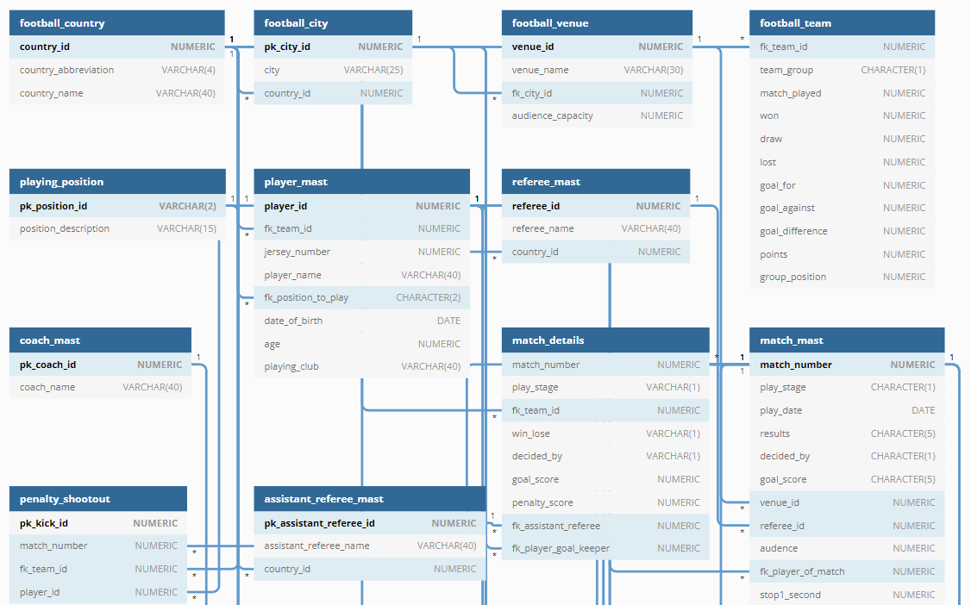

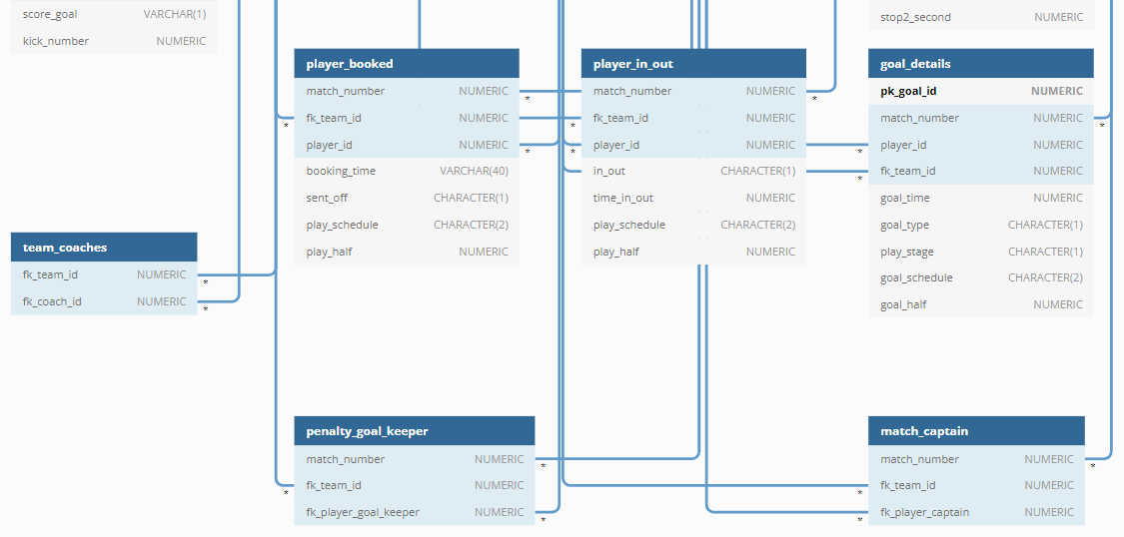

Де “1” – один, а “*” багато.

2.3 ЛОГІЧНА МОДЕЛЬ БАЗИ ДАНИХ

Логічна модель бази даних згенерована з допомогою СУБД представлена нижче:

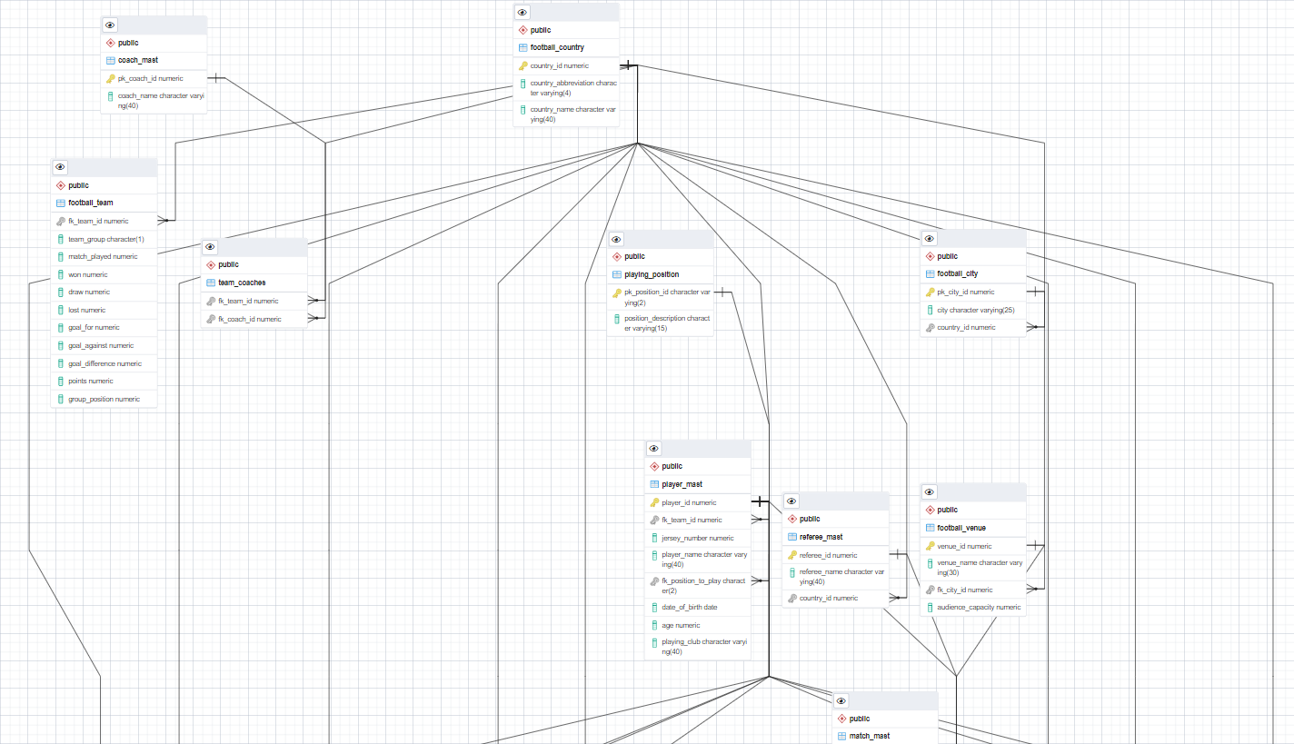

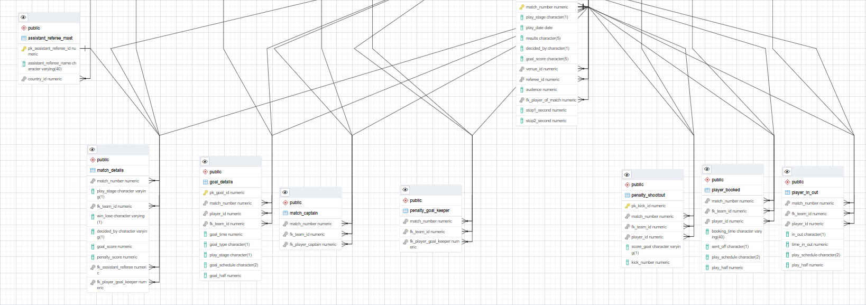

2.5 ПРОГРАМНА РЕАЛІЗАЦІЯ

2.5.1 Створення бази даних

Створення бази даних та користувачів наступним скриптом:

-- Створення бази даних та користувачів

CREATE USER "FootballChampionshipOwner" WITH PASSWORD 'Football_Championship_Owner';

CREATE DATABASE "FootballChampionshipDB" OWNER "FootballChampionshipOwner";

ALTER DATABASE "FootballChampionshipDB" SET TIMEZONE = 'UTC';

GRANT ALL PRIVILEGES ON DATABASE "FootballChampionshipDB" TO "FootballChampionshipOwner";

CREATE USER "FootballChampionshipReader" WITH PASSWORD 'Football_Championship_Reader';

GRANT CONNECT ON DATABASE "FootballChampionshipDB" TO "FootballChampionshipReader";

GRANT USAGE ON SCHEMA public TO "FootballChampionshipReader";

GRANT SELECT ON ALL TABLES IN SCHEMA public TO "FootballChampionshipReader";

Створення таблиць наступним скриптом:

-- Створення таблиць

--

CREATE TABLE IF NOT EXISTS football_country

(

country_id NUMERIC PRIMARY KEY,

country_abbreviation VARCHAR(4),

country_name VARCHAR(40)

);

--

CREATE TABLE IF NOT EXISTS football_city

(

pk_city_id NUMERIC PRIMARY KEY,

city VARCHAR(25),

country_id NUMERIC REFERENCES football_country(country_id)

);

--

CREATE TABLE IF NOT EXISTS football_venue

(

venue_id NUMERIC PRIMARY KEY,

venue_name VARCHAR(30),

fk_city_id NUMERIC REFERENCES football_city(pk_city_id),

audience_capacity NUMERIC

);

--

CREATE TABLE IF NOT EXISTS football_team

(

fk_team_id NUMERIC REFERENCES football_country(country_id),

team_group CHARACTER(1),

match_played NUMERIC,

won NUMERIC,

draw NUMERIC,

lost NUMERIC,

goal_for NUMERIC,

goal_against NUMERIC,

goal_difference NUMERIC,

points NUMERIC,

group_position NUMERIC

);

--

CREATE TABLE IF NOT EXISTS playing_position

(

pk_position_id VARCHAR(2) PRIMARY KEY,

position_description VARCHAR(15)

);

--

CREATE TABLE IF NOT EXISTS player_mast

(

player_id NUMERIC PRIMARY KEY,

fk_team_id NUMERIC REFERENCES football_country(country_id),

jersey_number NUMERIC,

player_name VARCHAR(40),

fk_position_to_play CHARACTER(2) REFERENCES playing_position(pk_position_id),

date_of_birth DATE,

age NUMERIC,

playing_club VARCHAR(40)

);

--

CREATE TABLE IF NOT EXISTS referee_mast

(

referee_id NUMERIC PRIMARY KEY,

referee_name VARCHAR(40),

country_id NUMERIC REFERENCES football_country(country_id)

);

--

CREATE TABLE IF NOT EXISTS match_mast

(

match_number NUMERIC PRIMARY KEY,

play_stage CHARACTER(1),

play_date DATE,

results CHARACTER(5),

decided_by CHARACTER(1),

goal_score CHARACTER(5),

venue_id NUMERIC REFERENCES football_venue(venue_id),

referee_id NUMERIC REFERENCES referee_mast(referee_id),

audence NUMERIC,

fk_player_of_match NUMERIC REFERENCES player_mast(player_id),

stop1_second NUMERIC,

stop2_second NUMERIC

);

--

CREATE TABLE IF NOT EXISTS coach_mast

(

pk_coach_id NUMERIC PRIMARY KEY,

coach_name VARCHAR(40)

);

--

CREATE TABLE IF NOT EXISTS assistant_referee_mast

(

pk_assistant_referee_id NUMERIC PRIMARY KEY,

assistant_referee_name VARCHAR(40),

country_id NUMERIC REFERENCES football_country(country_id)

);

--

CREATE TABLE IF NOT EXISTS match_details

(

match_number NUMERIC REFERENCES match_mast(match_number),

play_stage VARCHAR(1),

fk_team_id NUMERIC REFERENCES football_country(country_id),

win_lose VARCHAR(1),

decided_by VARCHAR(1),

goal_score NUMERIC,

penalty_score NUMERIC,

fk_assistant_referee NUMERIC REFERENCES assistant_referee_mast(pk_assistant_referee_id),

fk_player_goal_keeper NUMERIC REFERENCES player_mast(player_id)

);

--

CREATE TABLE IF NOT EXISTS goal_details

(

pk_goal_id NUMERIC PRIMARY KEY,

match_number NUMERIC REFERENCES match_mast(match_number),

player_id NUMERIC REFERENCES player_mast(player_id),

fk_team_id NUMERIC REFERENCES football_country(country_id),

goal_time NUMERIC,

goal_type CHARACTER(1),

play_stage CHARACTER(1),

goal_schedule CHARACTER(2),

goal_half NUMERIC

);

--

CREATE TABLE IF NOT EXISTS penalty_shootout

(

pk_kick_id NUMERIC PRIMARY KEY,

match_number NUMERIC REFERENCES match_mast(match_number),

fk_team_id NUMERIC REFERENCES football_country(country_id),

player_id NUMERIC REFERENCES player_mast(player_id),

score_goal VARCHAR(1),

kick_number NUMERIC

);

--

CREATE TABLE IF NOT EXISTS player_booked

(

match_number NUMERIC REFERENCES match_mast(match_number),

fk_team_id NUMERIC REFERENCES football_country(country_id),

player_id NUMERIC REFERENCES player_mast(player_id),

booking_time VARCHAR(40),

sent_off CHARACTER(1),

play_schedule CHARACTER(2),

play_half NUMERIC

);

--

CREATE TABLE IF NOT EXISTS player_in_out

(

match_number NUMERIC REFERENCES match_mast(match_number),

fk_team_id NUMERIC REFERENCES football_country(country_id),

player_id NUMERIC REFERENCES player_mast(player_id),

in_out CHARACTER(1),

time_in_out NUMERIC,

play_schedule CHARACTER(2),

play_half NUMERIC

);

--

CREATE TABLE IF NOT EXISTS match_captain

(

match_number NUMERIC REFERENCES match_mast(match_number),

fk_team_id NUMERIC REFERENCES football_country(country_id),

fk_player_captain NUMERIC REFERENCES player_mast(player_id)

);

--

CREATE TABLE IF NOT EXISTS team_coaches

(

fk_team_id NUMERIC REFERENCES football_country(country_id),

fk_coach_id NUMERIC REFERENCES coach_mast(pk_coach_id)

);

--

CREATE TABLE IF NOT EXISTS penalty_goal_keeper

(

match_number NUMERIC REFERENCES match_mast(match_number),

fk_team_id NUMERIC REFERENCES football_country(country_id),

fk_player_goal_keeper NUMERIC REFERENCES player_mast(player_id)

);

2.5.2 Наповнення таблиць даними

Наповнення таблиць даними наступними командами:

-- Втавлення даних в таблиці

\copy football_country FROM 'C:\Users\User\Desktop\CourseWork\CSV\football_country.csv' DELIMITER ';' CSV

\copy football_city FROM 'C:\Users\User\Desktop\CourseWork\CSV\football_city.csv' DELIMITER ';' CSV

\copy football_venue FROM 'C:\Users\User\Desktop\CourseWork\CSV\football_venue.csv' DELIMITER ';' CSV

\copy football_team FROM 'C:\Users\User\Desktop\CourseWork\CSV\football_team.csv' DELIMITER ';' CSV

\copy referee_mast FROM 'C:\Users\User\Desktop\CourseWork\CSV\referee_mast.csv' DELIMITER ';' CSV

\copy coach_mast FROM 'C:\Users\User\Desktop\CourseWork\CSV\coach_mast.csv' DELIMITER ';' CSV

\copy assistant_referee_mast FROM 'C:\Users\User\Desktop\CourseWork\CSV\assistant_referee_mast.csv' DELIMITER ';' CSV

\copy team_coaches FROM 'C:\Users\User\Desktop\CourseWork\CSV\team_coaches.csv' DELIMITER ';' CSV

\copy playing_position FROM 'C:\Users\User\Desktop\CourseWork\CSV\playing_position.csv' DELIMITER ';' CSV

\copy player_mast FROM 'C:\Users\User\Desktop\CourseWork\CSV\player_mast.csv' DELIMITER ';' CSV

\copy match_mast FROM 'C:\Users\User\Desktop\CourseWork\CSV\match_mast.csv' DELIMITER ';' CSV

\copy match_details FROM 'C:\Users\User\Desktop\CourseWork\CSV\match_details.csv' DELIMITER ';' CSV

\copy penalty_shootout FROM 'C:\Users\User\Desktop\CourseWork\CSV\penalty_shootout.csv' DELIMITER ';' CSV

\copy player_booked FROM 'C:\Users\User\Desktop\CourseWork\CSV\player_booked.csv' DELIMITER ';' CSV

\copy player_in_out FROM 'C:\Users\User\Desktop\CourseWork\CSV\player_in_out.csv' DELIMITER ';' CSV

\copy match_captain FROM 'C:\Users\User\Desktop\CourseWork\CSV\match_captain.csv' DELIMITER ';' CSV

\copy penalty_goal_keeper FROM 'C:\Users\User\Desktop\CourseWork\CSV\penalty_goal_keeper.csv' DELIMITER ';' CSV

\copy goal_details FROM 'C:\Users\User\Desktop\CourseWork\CSV\goal_details.csv' DELIMITER ';' CSV

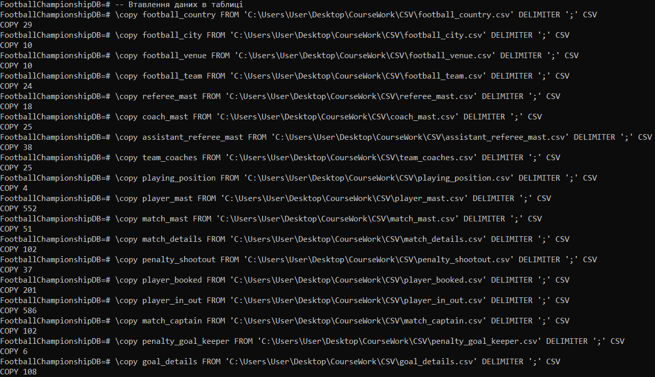

Файли з яких читають дані було додано до ГітХаб.

2.5.3 Створення запитів

Нижче наведено скрипти для вибірки даних:

-- Запити для вибірки даних

--

SELECT c.match_number,a.country_name AS "Team",

b.player_name, b.jersey_number, c.score_goal ,c.kick_number

FROM football_country a, penalty_shootout c, player_mast b

WHERE c.fk_team_id=a.country_id

AND c.player_id=b.player_id;

--

SELECT a.country_name, COUNT(b.*) as "Number of Shots"

FROM football_country a, penalty_shootout b

WHERE b.fk_team_id=a.country_id

GROUP BY a.country_name;

--

SELECT play_half,play_schedule,COUNT(*)

FROM player_booked

WHERE play_schedule='NT'

GROUP BY play_half,play_schedule;

--

SELECT play_half,play_schedule,COUNT(*)

FROM player_in_out

WHERE in_out='I'

GROUP BY play_half,play_schedule

ORDER BY play_half,play_schedule,count(*) DESC;

--

SELECT COUNT(goal_score)

FROM match_details

WHERE win_lose='W'

AND decided_by<>'P'

AND goal_score=1;

-- Запити з підзапитами для вибірки даних

--

SELECT match_number,country_name, player_name, COUNT(match_number)

FROM goal_details a, football_country b, player_mast c

WHERE a.fk_team_id=b.country_id

AND a.player_id=c.player_id

GROUP BY match_number,country_name,player_name

ORDER BY match_number;

--

SELECT country_name

FROM football_country

WHERE country_id IN(

SELECT fk_team_id

FROM goal_details

WHERE match_number=(

SELECT match_number

FROM match_mast

WHERE audence=(

SELECT max(audence)

FROM match_mast)

ORDER BY audence DESC));

--

SELECT player_name,jersey_number

FROM player_mast

WHERE player_id=(

SELECT player_id

FROM goal_details

WHERE goal_type='P' AND match_number=(

SELECT MIN(match_number)

FROM goal_details

WHERE goal_type='P' AND play_stage='G'));

--

SELECT MAX(stop2_second)

FROM match_mast

WHERE stop2_second<>(

SELECT MAX(stop2_second)

FROM match_mast);

--

SELECT country_name

FROM football_country

WHERE country_id IN(

SELECT fk_team_id

FROM match_details

WHERE match_number IN(

SELECT match_number

FROM match_mast

WHERE stop2_second=(

SELECT max(stop2_second)

FROM match_mast

WHERE stop2_second<>(

SELECT max(stop2_second)

FROM match_mast))));

-- Запити з JOIN для вибірки даних

--

SELECT match_details.match_number, football_country.country_name

FROM match_mast

JOIN match_details

ON match_mast.match_number=match_details.match_number

JOIN football_country

ON match_details.fk_team_id=football_country.country_id

WHERE stop1_second=0;

--

SELECT country_name,team_group,match_played,

won,lost,goal_for,goal_against

FROM football_team

JOIN football_country

ON football_team.fk_team_id=football_country.country_id

WHERE goal_against=(

SELECT MAX(goal_against)

FROM football_team);

--

SELECT match_details.match_number, football_country.country_name,

match_mast.stop2_second as "Stoppage Time(sec.)"

FROM match_mast

JOIN match_details

ON match_mast.match_number=match_details.match_number

JOIN football_country

ON match_details.fk_team_id=football_country.country_id

WHERE stop2_second IN (

SELECT MAX(stop2_second)

FROM match_mast);

--

SELECT match_number,country_name

FROM match_details

JOIN football_country ON football_country.country_id=match_details.fk_team_id

WHERE win_lose='D' AND goal_score=0 AND play_stage='G'

ORDER BY match_number;

--

SELECT a.match_number, c.country_name, a.stop2_second

FROM match_mast a

JOIN match_details b ON a.match_number=b.match_number

JOIN football_country c ON b.fk_team_id=c.country_id

WHERE (2-1) = (

SELECT COUNT(DISTINCT(b.stop2_second))

FROM match_mast b

WHERE b.stop2_second > a.stop2_second);

--

SELECT b.country_name,c.player_name,COUNT(a.fk_player_goal_keeper) count_gk

FROM match_details a

JOIN football_country b ON a.fk_team_id=b.country_id

JOIN player_mast c ON a.fk_player_goal_keeper=c.player_id

GROUP BY b.country_name,c.player_name

ORDER BY country_name,player_name,count_gk DESC;

--

SELECT venue_name, count(venue_name)

FROM goal_details

JOIN football_country

ON goal_details.fk_team_id=football_country.country_id

JOIN match_mast ON goal_details.match_number=match_mast.match_number

JOIN football_venue ON match_mast.venue_id=football_venue.venue_id

GROUP BY venue_name

HAVING COUNT (venue_name)=(

SELECT MAX(mycount)

FROM (

SELECT venue_name, COUNT(venue_name) mycount

FROM goal_details

JOIN football_country

ON goal_details.fk_team_id=football_country.country_id

JOIN match_mast ON goal_details.match_number=match_mast.match_number

JOIN football_venue ON match_mast.venue_id=football_venue.venue_id

GROUP BY venue_name) gd);

--

SELECT a.country_name,b.player_name,b.jersey_number,b.age

FROM football_country a

JOIN player_mast b

ON a.country_id=b.fk_team_id

WHERE b.age IN (

SELECT MAX(age)

FROM player_mast);

--

SELECT match_number,country_name

FROM match_details a

JOIN football_country b

ON a.fk_team_id=b.country_id

WHERE goal_score=3 AND win_lose='D';

--

SELECT a.country_name as Team , b.team_group,b.match_played,

b.goal_against, b.group_position

FROM football_country a

JOIN football_team b

ON a.country_id=b.fk_team_id

WHERE goal_against=4 AND group_position=4

ORDER BY team_group;

Нижче в додаток А додано результати виконання всіх запитів.

2.5.4 Використання процедури

Нижче наведено приклад створення і використання процедури:

-- Створення процедури

CREATE OR REPLACE PROCEDURE create_temp_table_football_country()

AS

$$

BEGIN

CREATE TEMP TABLE IF NOT EXISTS temp_table_football_country AS

SELECT concat(FC.country_abbreviation, ' ', FC.country_name)

FROM football_country AS FC;

END;

$$ LANGUAGE plpgsql;

CALL create_temp_table_football_country();

SELECT *

FROM temp_table_football_country;

DROP TABLE IF EXISTS temp_table_football_country;

Нижче в додаток Б додано результат використання процедури.

2.5.5 Використання тригера

Нижче наведено приклад створення тригера:

-- Створення тригера

CREATE TRIGGER person_validate_insert

BEFORE INSERT

ON penalty_shootout

FOR EACH ROW

BEGIN

IF NEW.score_goal NOT LIKE 'Y' OR 'N' THEN

SIGNAL SQLSTATE VALUE '45000'

SET MESSAGE_TEXT = '[table:penalty_shootout] - score_goal column is not valid';

END IF;

END;

2.5.6 Використання представлення

Нижче наведено приклад створення і використання представлення:

-- Створення представлення

--

CREATE VIEW "Number of matches played by Germany" AS

SELECT match_number,

country_name

FROM penalty_shootout a

JOIN football_country c ON a.fk_team_id=c.country_id

WHERE match_number=

(SELECT match_number

FROM penalty_shootout

WHERE pk_kick_id=26)

AND country_name<>

(SELECT country_name

FROM football_country

WHERE country_id=

(SELECT fk_team_id

FROM penalty_shootout

WHERE pk_kick_id=26))

GROUP BY match_number,

country_name;

-- Отримання даних з представлення

SELECT * FROM "Number of matches played by Germany";

Нижче в додаток Б додано результат використання представлення.

2.5.7 Використання функції

Нижче наведено приклад створення і використання функції:

-- Створення функції

CREATE OR REPLACE FUNCTION check_if_table_exists(schema_name VARCHAR, _table_name VARCHAR)

RETURNS BOOLEAN

AS

$$

SELECT EXISTS(

SELECT

FROM information_schema.tables

WHERE table_schema = schema_name

AND table_name = _table_name

);

$$ LANGUAGE sql;

-- Перевірка роботи функції

SELECT check_if_table_exists('public', 'football_country');

Нижче в додаток Б додано результат використання функції.

ВИСНОВКИ

Метою даної курсової роботи була реалізація бази даних для футбольних чемпіонатів. База даних була успішно протестована з допомогою запитів для вибірки даних, процедур функцій, представлень. Дана база даних є актуальною і зможе знайти широке застосування. Вона є відкритою до покращень та розширень.

Завдання курсової роботи було виконане в повній мірі:

створено користувачів бази даних;

реалізовано більше десяти таблиць: 18;

імпортовано дані;

реалізовано більше двадцяти запитів: 123, в роботі наведено виконання лише двадцяти, але нижче в додатку В наведено скрипти усіх;

створено і використано процедуру;

створено тригер;

створено і використано представлення;

створено і використано функцію.

СПИСОК ВИКОРИСТАНОЇ ЛІТЕРАТУРИ

1. SQL. Повне керівництво. Джеймс Р. Грофф, Пол Н. Вайнберг, Ендрю Дж. Оппель. Видавництво «Вільямс» – 2015.
2. SQL та реляційна теорія. К. Дж. Дейт. Видавництво «Вільямс» – 2010.
3. github.com – [Електронний ресурс] – 2021. Режим доступу до ресурсу: <https://github.com/iamnno/CourseWork_DB>
4. dbdiagram.io – [Електронний ресурс] – 2021. Режим доступу до ресурсу: <https://dbdiagram.io/embed/61c28fa73205b45b73c8246c>

ДОДАТКИ

ДОДАТОКА

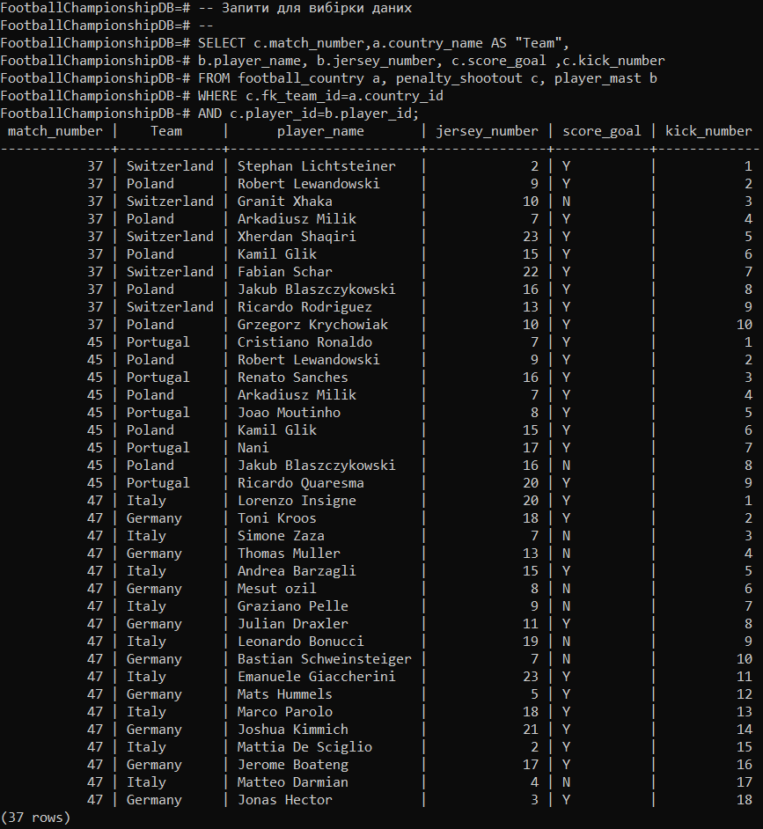

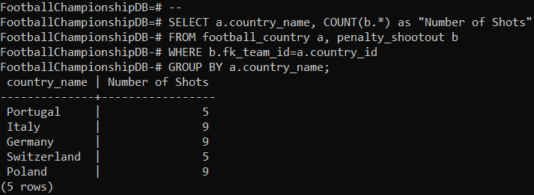

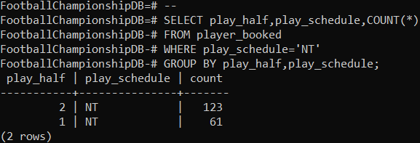

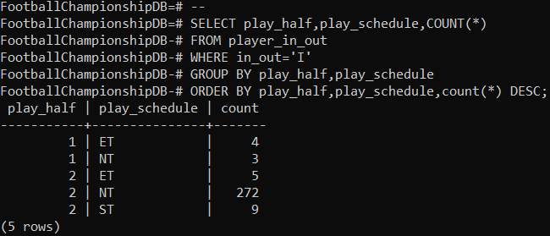

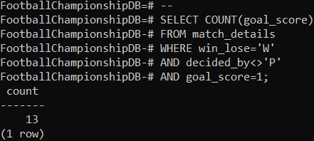

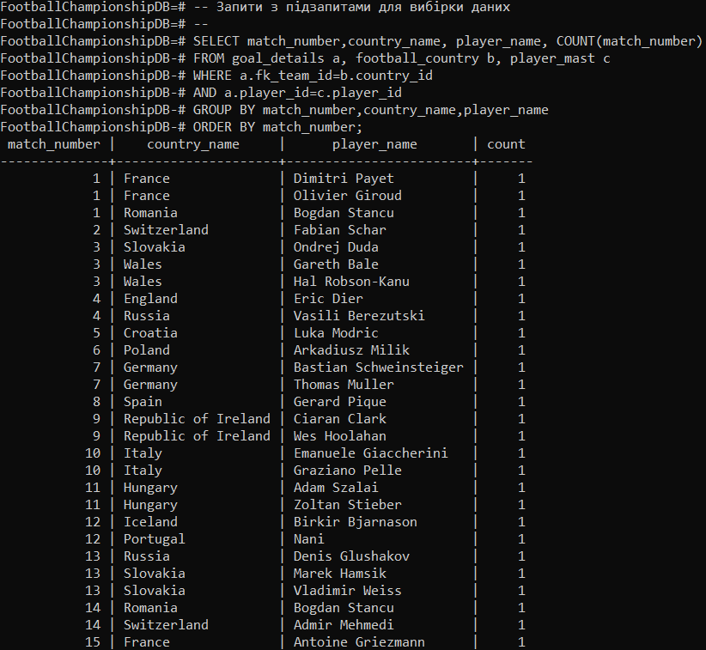

В запиті вище результатом є сто рядків

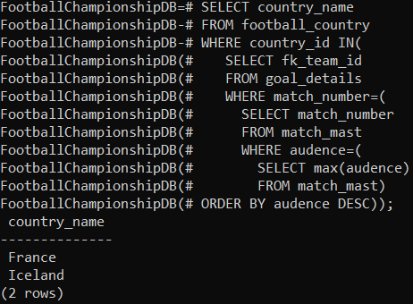

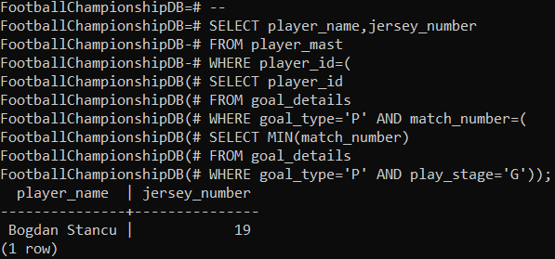

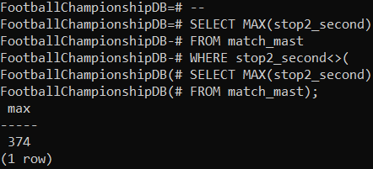

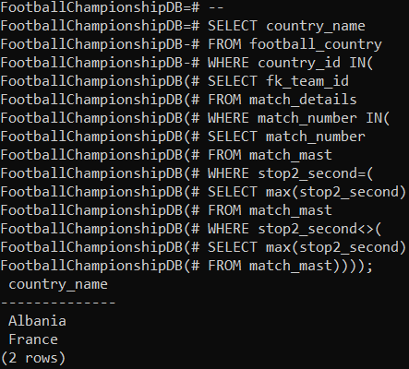

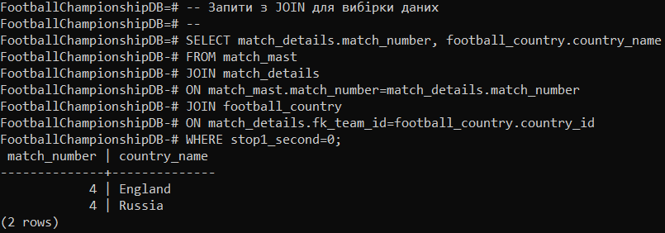

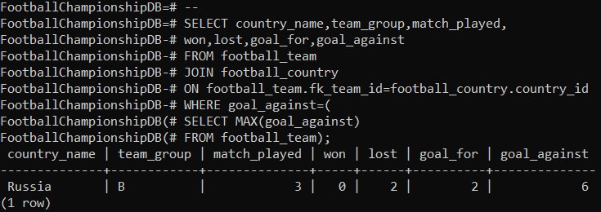

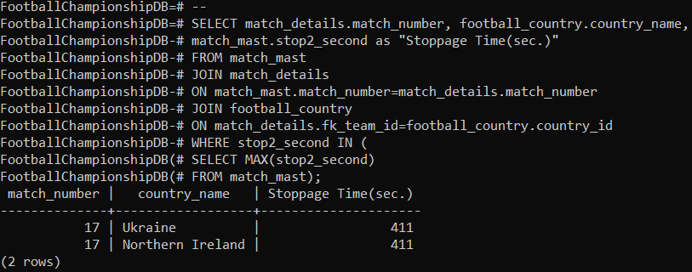

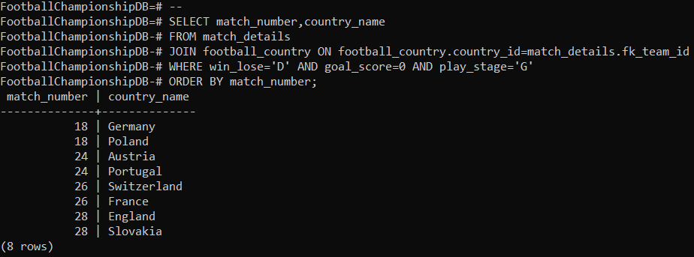

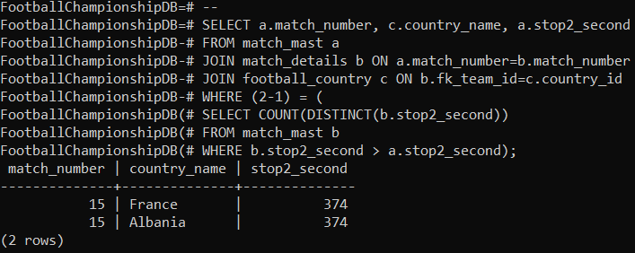

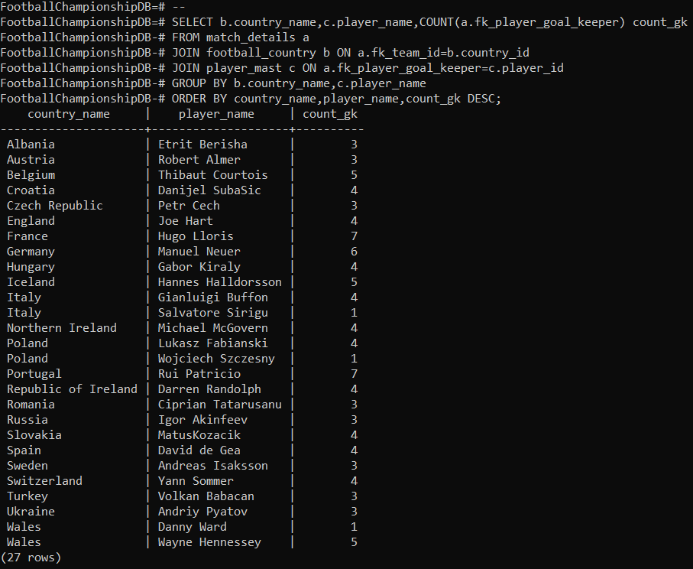

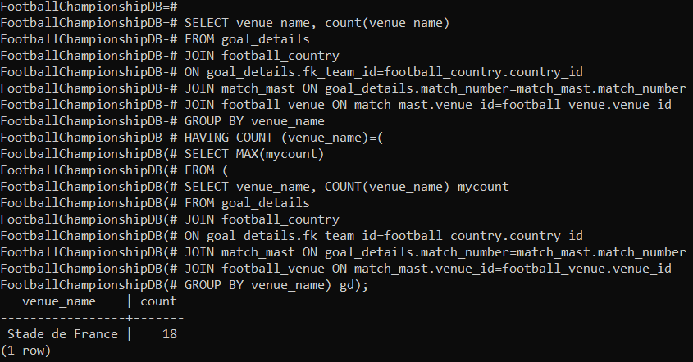

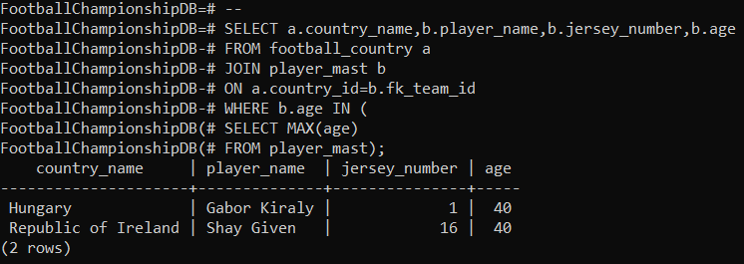

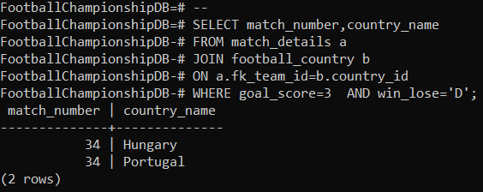

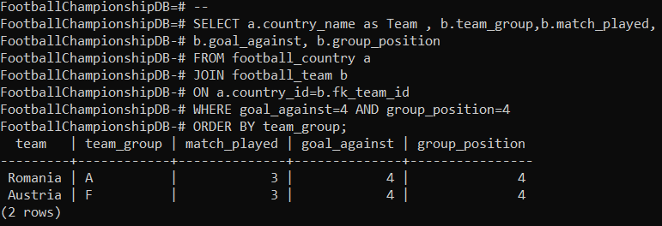

ДОДАТОКБ

Процедура:

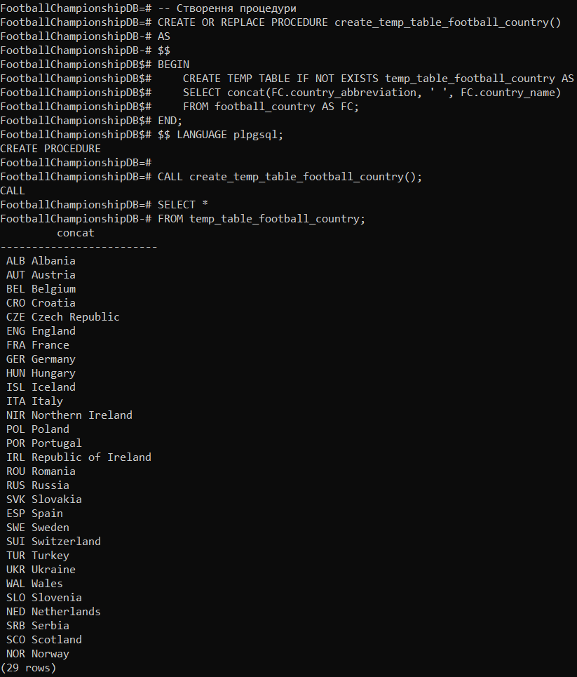



Представлення:

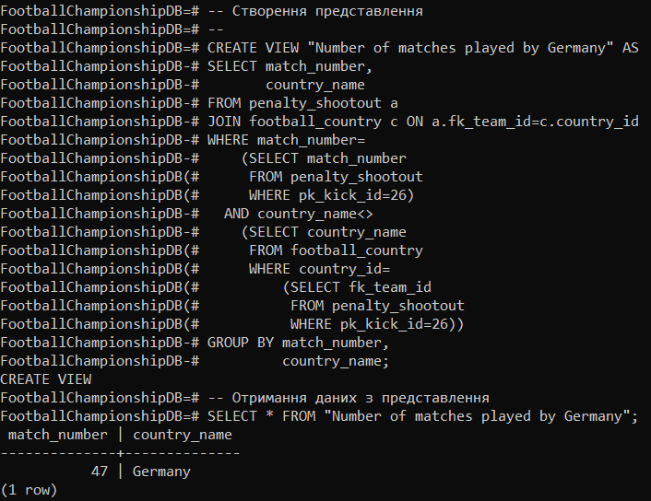

Функція:

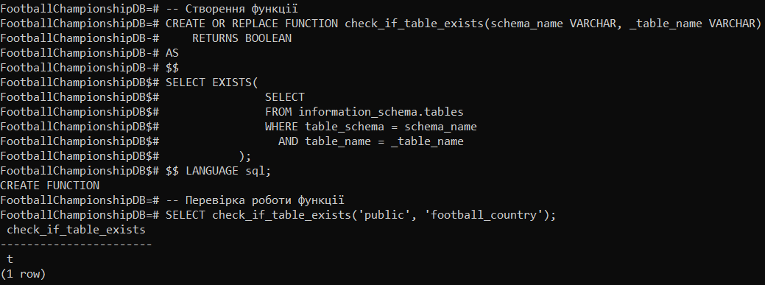

ДОДАТОКВ

-- Запити для вибірки даних

--

SELECT COUNT(*)

FROM football_venue;

--

SELECT COUNT(DISTINCT fk_team_id)

FROM player_mast;

--

SELECT COUNT(*)

FROM goal_details;

--

SELECT COUNT(*)

FROM match_mast

WHERE results='WIN';

--

SELECT COUNT(*)

FROM match_mast

WHERE results='DRAW';

--

SELECT play_date "Beginning Date"

FROM match_mast

WHERE match_number=1;

--

SELECT COUNT(*)

FROM goal_details

WHERE goal_type='O';

--

SELECT COUNT(*)

FROM match_mast

WHERE results='WIN'

AND play_stage='G';

--

SELECT COUNT(DISTINCT match_number)

FROM penalty_shootout;

--

SELECT COUNT(*)

FROM match_mast

WHERE decided_by='P' AND play_stage='R';

--

SELECT match_number,COUNT(*)

FROM goal_details

GROUP BY match_number

ORDER BY match_number;

--

SELECT match_number, play_date, goal_score

FROM match_mast

WHERE stop1_second=0;

--

SELECT COUNT(DISTINCT(match_number))

FROM match_details

WHERE win_lose='D'

AND goal_score=0 AND play_stage='G';

--

SELECT COUNT(goal_score)

FROM match_details

WHERE win_lose='W'

AND decided_by<>'P'

AND goal_score=1;

--

SELECT COUNT(*) as "Player Replaced"

FROM player_in_out

WHERE in_out='I';

--

SELECT COUNT(*) as "Player Replaced"

FROM player_in_out

WHERE in_out='I'

AND play_schedule='NT';

--

SELECT COUNT(*) as "Player Replaced"

FROM player_in_out

WHERE in_out='I'

AND play_schedule='ST';

--

SELECT COUNT(*) as "Player Replaced"

FROM player_in_out

WHERE in_out='I'

AND play_schedule='NT'

AND play_half=1;

--

SELECT COUNT(DISTINCT match_number)

FROM match_details

WHERE win_lose='D'

AND goal_score=0;

--

SELECT COUNT(*)

FROM player_in_out

WHERE play_schedule='ET'

AND in_out='I';

--

SELECT play_half,play_schedule,COUNT(*)

FROM player_in_out

WHERE in_out='I'

GROUP BY play_half,play_schedule

ORDER BY play_half,play_schedule,count(*) DESC;

--

SELECT COUNT(*) AS "Number of Penalty Kicks"

FROM penalty_shootout;

--

SELECT COUNT(*) AS "Goal Scored by Penalty Kicks"

FROM penalty_shootout

WHERE score_goal='Y';

--

SELECT COUNT(*) AS "Goal missed or saved by Penalty Kicks"

FROM penalty_shootout

WHERE score_goal='N';

--

SELECT c.match_number,a.country_name AS "Team",

b.player_name, b.jersey_number, c.score_goal ,c.kick_number

FROM football_country a, penalty_shootout c, player_mast b

WHERE c.fk_team_id=a.country_id

AND c.player_id=b.player_id;

--

SELECT a.country_name, COUNT(b.*) as "Number of Shots"

FROM football_country a, penalty_shootout b

WHERE b.fk_team_id=a.country_id

GROUP BY a.country_name;

--

SELECT play_half,play_schedule,COUNT(*)

FROM player_booked

WHERE play_schedule='NT'

GROUP BY play_half,play_schedule;

--

SELECT COUNT(*)

FROM player_booked

WHERE play_schedule='ST';

--

SELECT COUNT(*)

FROM player_booked

WHERE play_schedule='ET';

-- Запити з підзапитами для вибірки даних

--

SELECT match_number,country_name

FROM match_details a, football_country b

WHERE a.fk_team_id=b.country_id

AND a.match_number=1;

--

SELECT country_name as Team

FROM football_country

WHERE country_id in (

SELECT fk_team_id

FROM match_details

WHERE play_stage='F' and win_lose='W');

--

SELECT match_number, play_stage, goal_score, audence

FROM match_mast

WHERE audence=(

SELECT max(audence)

FROM match_mast);

--

SELECT match_number

FROM match_details

WHERE fk_team_id=(

SELECT country_id

FROM football_country

WHERE country_name='Germany')

OR fk_team_id=(

SELECT country_id

FROM football_country

WHERE country_name='Poland')

GROUP BY match_number

HAVING COUNT(DISTINCT fk_team_id)=2;

--

SELECT match_number, play_stage, play_date, results, goal_score

FROM match_mast

WHERE match_number

IN(

SELECT match_number

FROM match_details

WHERE fk_team_id=(

SELECT country_id

FROM football_country

WHERE country_name='Portugal') OR fk_team_id=(

SELECT country_id

FROM football_country

WHERE country_name='Hungary')

GROUP BY match_number

HAVING COUNT(DISTINCT fk_team_id)=2);

--

SELECT match_number,country_name, player_name, COUNT(match_number)

FROM goal_details a, football_country b, player_mast c

WHERE a.fk_team_id=b.country_id

AND a.player_id=c.player_id

GROUP BY match_number,country_name,player_name

ORDER BY match_number;

--

SELECT country_name

FROM football_country

WHERE country_id IN(

SELECT fk_team_id

FROM goal_details

WHERE match_number=(

SELECT match_number

FROM match_mast

WHERE audence=(

SELECT max(audence)

FROM match_mast)

ORDER BY audence DESC));

--

SELECT player_name

FROM player_mast

WHERE player_id=(

SELECT player_id

FROM goal_details

where match_number=(SELECT match_number FROM match_details

WHERE fk_team_id=(

SELECT country_id FROM football_country

WHERE country_name='Hungary')

or fk_team_id=(SELECT country_id FROM football_country

WHERE country_name='Portugal')

GROUP BY match_number HAVING COUNT(DISTINCT fk_team_id)=2)

AND fk_team_id=(SELECT fk_team_id

FROM football_country a, football_team b

WHERE a.country_id=b.fk_team_id AND country_name='Portugal')

AND goal_time=(

SELECT max(goal_time)

FROM goal_details

WHERE match_number=(SELECT match_number FROM match_details

WHERE fk_team_id=(

SELECT country_id FROM football_country

WHERE country_name='Hungary')

or fk_team_id=(SELECT country_id FROM football_country

WHERE country_name='Portugal')

GROUP BY match_number HAVING COUNT(DISTINCT fk_team_id)=2) AND fk_team_id=(

SELECT fk_team_id

FROM football_country a, football_team b

WHERE a.country_id=b.fk_team_id AND country_name='Portugal'))

);

--

SELECT MAX(stop2_second)

FROM match_mast

WHERE stop2_second<>(

SELECT MAX(stop2_second)

FROM match_mast);

--

SELECT country_name

FROM football_country

WHERE country_id IN(

SELECT fk_team_id

FROM match_details

WHERE match_number IN(

SELECT match_number

FROM match_mast

WHERE stop2_second=(

SELECT max(stop2_second)

FROM match_mast

WHERE stop2_second<>(

SELECT max(stop2_second)

FROM match_mast))));

--

SELECT match_number,play_date,stop2_second

FROM match_mast a

WHERE (2-1) = (

SELECT COUNT(DISTINCT(b.stop2_second))

FROM match_mast b

WHERE b.stop2_second > a.stop2_second);

--

SELECT country_name

FROM football_country

WHERE country_id=(

SELECT fk_team_id

FROM match_details

WHERE play_stage='F'

AND fk_team_id<>(

SELECT country_id

FROM football_country

WHERE country_name='Portugal'));

--

SELECT playing_club, COUNT(playing_club)

FROM player_mast GROUP BY playing_club

HAVING COUNT (playing_club)=(

SELECT MAX(mycount)

FROM (

SELECT playing_club, COUNT(playing_club) mycount

FROM player_mast

GROUP BY playing_club) pm);

--

SELECT player_name,jersey_number

FROM player_mast

WHERE player_id=(

SELECT player_id

FROM goal_details

WHERE goal_type='P' AND match_number=(

SELECT MIN(match_number)

FROM goal_details

WHERE goal_type='P' AND play_stage='G'));

--

SELECT a.player_name,a.jersey_number,d.country_name

FROM player_mast a, goal_details b, goal_details c, football_country d

WHERE a.player_id=b.player_id AND a.fk_team_id=d.country_id AND

a.player_id=(

SELECT b.player_id

FROM goal_details b

WHERE b.goal_type='P' AND b.match_number=(

SELECT MIN(c.match_number)

FROM goal_details c

WHERE c.goal_type='P' AND c.play_stage='G'))

GROUP BY player_name,jersey_number,country_name;

--

SELECT player_name

FROM player_mast

WHERE player_id=(

SELECT fk_player_goal_keeper

FROM penalty_goal_keeper

WHERE match_number=(

SELECT match_number

FROM penalty_goal_keeper

WHERE fk_team_id=(

SELECT country_id

FROM football_country

WHERE country_name='Italy')

OR fk_team_id=(

SELECT country_id

FROM football_country

WHERE country_name='Germany')

GROUP BY match_number

HAVING COUNT(DISTINCT fk_team_id)=2

)

AND fk_team_id=(

SELECT country_id

FROM football_country

WHERE country_name='Italy')

);

--

SELECT COUNT(player_id)

FROM goal_details

WHERE fk_team_id=

(

SELECT country_id

FROM football_country

WHERE country_name='Germany'

);

--

SELECT player_name, jersey_number, playing_club

FROM player_mast

WHERE fk_position_to_play='GK' AND fk_team_id=(

SELECT country_id

FROM football_country

WHERE country_name='England');

--

SELECT player_name, jersey_number, fk_position_to_play, age

FROM player_mast

WHERE playing_club='Liverpool'

AND fk_team_id=(

SELECT country_id

FROM football_country

WHERE country_name='England'

);

--

SELECT a.player_name, b.goal_time, b.goal_half, c.country_name

FROM player_mast a, goal_details b,football_country c

WHERE a.player_id=b.player_id

AND b.fk_team_id=c.country_id

AND match_number=50

AND goal_time= (

SELECT MAX(goal_time)

FROM goal_details

WHERE match_number=50);

--

SELECT player_name

FROM player_mast

WHERE player_id IN (

SELECT fk_player_captain

FROM match_captain

WHERE fk_team_id=(

SELECT fk_team_id

FROM match_details

WHERE play_stage='F' AND win_lose='W'));

--

SELECT COUNT(*)+11 as "Number of players shared fields"

FROM player_in_out

WHERE match_number=(

SELECT match_number

FROM match_mast

WHERE play_stage='F')

AND in_out='I'

AND fk_team_id=(

SELECT country_id

FROM football_country

WHERE country_name='France');

--

SELECT player_name,jersey_number

FROM player_mast

WHERE player_id IN(

SELECT fk_player_goal_keeper

FROM match_details

WHERE play_stage='G' and fk_team_id IN(

SELECT country_id

FROM football_country

WHERE country_name='Germany'));

--

SELECT country_name

FROM football_country

WHERE country_id=(

SELECT fk_team_id

FROM match_details

WHERE play_stage='F' AND win_lose='L'

AND fk_team_id<>(

SELECT country_id

FROM football_country

WHERE country_name='Portugal'));

--

SELECT a.country_name, COUNT(b.*) shots

FROM football_country a, penalty_shootout b

WHERE b.fk_team_id=a.country_id

GROUP BY a.country_name

having COUNT(b.*)=(

SELECT MAX(shots) FROM (

SELECT COUNT(*) shots

FROM penalty_shootout

GROUP BY fk_team_id) inner_result);

--

SELECT c.country_name,a.player_name, a.jersey_number,COUNT(b.*) shots

FROM player_mast a, penalty_shootout b, football_country c

WHERE b.player_id=a.player_id

AND b.fk_team_id=c.country_id

GROUP BY c.country_name,a.player_name,a.jersey_number

HAVING COUNT(b.*)=(

SELECT MAX(shots) FROM (

SELECT COUNT(*) shots

FROM penalty_shootout

GROUP BY player_id) inner_result);

--

SELECT match_number,

COUNT(*) shots

FROM penalty_shootout

GROUP BY match_number

HAVING COUNT(*)=

(SELECT MAX(shots)

FROM

(SELECT COUNT(*) shots

FROM penalty_shootout

GROUP BY match_number) inner_result);

--

SELECT b.match_number,

a.country_name

FROM penalty_shootout b,

football_country a

WHERE b.fk_team_id=a.country_id

AND match_number=

(SELECT match_number

FROM penalty_shootout

GROUP BY match_number

HAVING COUNT(*)=

(SELECT MAX(shots)

FROM

(SELECT COUNT(*) shots

FROM penalty_shootout

GROUP BY match_number) inner_result))

GROUP BY b.match_number,

a.country_name;

--

SELECT a.match_number,

b.player_name,

a.kick_number

FROM penalty_shootout a,

player_mast b

WHERE a.player_id=b.player_id

AND kick_number=7

AND match_number=

(SELECT match_number

FROM penalty_shootout

WHERE fk_team_id =

(SELECT country_id

FROM football_country

WHERE country_name='Portugal' )

GROUP BY match_number)

GROUP BY match_number,

player_name,

pk_kick_id;

--

SELECT match_number,

play_stage

FROM match_mast

WHERE match_number=

(SELECT match_number

FROM penalty_shootout

WHERE pk_kick_id=23);

--

SELECT venue_name

FROM football_venue

WHERE venue_id IN

(SELECT venue_id

FROM match_mast

WHERE match_number IN

(SELECT DISTINCT match_number

FROM penalty_shootout));

--

SELECT play_date

FROM match_mast

WHERE match_number IN

(SELECT DISTINCT match_number

FROM penalty_shootout);

--

SELECT min(goal_time) AS "Most quickest goal after 5 minutes"

FROM

(SELECT match_number,

goal_time

FROM goal_details

WHERE goal_time>5

GROUP BY match_number,

goal_time

ORDER BY goal_time) hh;

-- Запити з JOIN для вибірки даних

--

SELECT venue_name, city

FROM football_venue a

JOIN football_city b ON a.pk_city_id=b.pk_city_id

JOIN match_mast d ON d.venue_id=a.venue_id

AND d.play_stage='F';

--

SELECT match_number,country_name,goal_score

FROM match_details a

JOIN football_country b

ON a.fk_team_id=b.country_id

WHERE decided_by='N'

ORDER BY match_number;

--

SELECT player_name,count(*),country_name

FROM goal_details a

JOIN player_mast b ON a.player_id=b.player_id

JOIN football_country c ON a.fk_team_id=c.country_id

WHERE goal_schedule = 'NT'

GROUP BY player_name,country_name

ORDER BY count(*) DESC;

--

SELECT player_name,country_name,count(player_name)

FROM goal_details gd

JOIN player_mast pm ON gd.player_id =pm.player_id

JOIN football_country sc ON pm.fk_team_id = sc.country_id

GROUP BY country_name,player_name HAVING COUNT(player_name) >= ALL

(SELECT COUNT(player_name)

FROM goal_details gd

JOIN player_mast pm ON gd.player_id =pm.player_id

JOIN football_country sc ON pm.fk_team_id = sc.country_id

GROUP BY country_name,player_name);

--

SELECT player_name,jersey_number,country_name

FROM goal_details a

JOIN player_mast b ON a.player_id=b.player_id

JOIN football_country c ON a.fk_team_id=c.country_id

WHERE play_stage='F';

--

SELECT country_name

FROM football_country a

JOIN football_city b ON a.country_id=b.country_id

JOIN football_venue c ON b.pk_city_id=c.pk_city_id

GROUP BY country_name;

--

SELECT a.player_name,a.jersey_number,b.country_name,c.goal_time,

c.play_stage,c.goal_schedule, c.goal_half

FROM player_mast a

JOIN football_country b

ON a.fk_team_id=b.country_id

JOIN goal_details c

ON c.player_id=a.player_id

WHERE pk_goal_id=1;

--

SELECT b.referee_name, c.country_name

FROM match_mast a

NATURAL JOIN referee_mast b

NATURAL JOIN football_country c

WHERE match_number=1;

--

SELECT b.referee_name, c.country_name

FROM match_mast a

NATURAL JOIN referee_mast b

NATURAL JOIN football_country c

WHERE play_stage='F';

--

SELECT assistant_referee_name, country_name

FROM assistant_referee_mast a

JOIN football_country b

ON a.country_id=b.country_id

JOIN match_details c

ON a.pk_assistant_referee_id=c.fk_assistant_referee

WHERE match_number=1;

--

SELECT assistant_referee_name, country_name

FROM assistant_referee_mast a

JOIN football_country b

ON a.country_id=b.country_id

JOIN match_details c

ON a.pk_assistant_referee_id=c.fk_assistant_referee

WHERE play_stage='F';

--

SELECT a.venue_name, b.city

FROM football_venue a

JOIN football_city b ON a.pk_city_id=b.pk_city_id

JOIN match_mast c ON a.venue_id=c.venue_id

WHERE match_number=1;

--

SELECT a.venue_name, b.city, a.aud_capacity, c.audence

FROM football_venue a

JOIN football_city b ON a.pk_city_id=b.pk_city_id

JOIN match_mast c ON a.venue_id=c.venue_id

WHERE play_stage='F';

--

SELECT a.venue_name, b.city, count(c.match_number)

FROM football_venue a

JOIN football_city b ON a.pk_city_id=b.pk_city_id

JOIN match_mast c ON a.venue_id=c.venue_id

GROUP BY venue_name,city

ORDER BY venue_name;

--

SELECT match_number, country_name, player_name,

booking_time as "sent_off_time", play_schedule, jersey_number

FROM player_booked a

JOIN player_mast b

ON a.player_id=b.player_id

JOIN football_country c

ON a.fk_team_id=c.country_id

AND a.sent_off='Y'

AND match_number=(

SELECT MIN(match_number)

from player_booked)

ORDER BY match_number,play_schedule,play_half,booking_time;

--

SELECT country_name as "Team" ,team_group, goal_for

FROM football_team

JOIN football_country

ON football_team.fk_team_id=football_country.country_id

AND goal_for=1;

--

SELECT country_name, COUNT(*)

FROM football_country

JOIN player_booked

ON football_country.country_id=player_booked.fk_team_id

GROUP BY country_name

ORDER BY COUNT(*) DESC;

--

SELECT venue_name, count(venue_name)

FROM goal_details

JOIN football_country

ON goal_details.fk_team_id=football_country.country_id

JOIN match_mast ON goal_details.match_number=match_mast.match_number

JOIN football_venue ON match_mast.venue_id=football_venue.venue_id

GROUP BY venue_name

ORDER BY COUNT(venue_name) DESC;

--

SELECT match_details.match_number, football_country.country_name

FROM match_mast

JOIN match_details

ON match_mast.match_number=match_details.match_number

JOIN football_country

ON match_details.fk_team_id=football_country.country_id

WHERE stop1_second=0;

--

SELECT country_name,team_group,match_played,

won,lost,goal_for,goal_against

FROM football_team

JOIN football_country

ON football_team.fk_team_id=football_country.country_id

WHERE goal_against=(

SELECT MAX(goal_against)

FROM football_team);

--

SELECT match_details.match_number, football_country.country_name,

match_mast.stop2_second as "Stoppage Time(sec.)"

FROM match_mast

JOIN match_details

ON match_mast.match_number=match_details.match_number

JOIN football_country

ON match_details.fk_team_id=football_country.country_id

WHERE stop2_second IN (

SELECT MAX(stop2_second)

FROM match_mast);

--

SELECT match_number,country_name

FROM match_details

JOIN football_country ON football_country.country_id=match_details.fk_team_id

WHERE win_lose='D' AND goal_score=0 AND play_stage='G'

ORDER BY match_number;

--

SELECT a.match_number, c.country_name, a.stop2_second

FROM match_mast a

JOIN match_details b ON a.match_number=b.match_number

JOIN football_country c ON b.fk_team_id=c.country_id

WHERE (2-1) = (

SELECT COUNT(DISTINCT(b.stop2_second))

FROM match_mast b

WHERE b.stop2_second > a.stop2_second);

--

SELECT b.country_name,c.player_name,COUNT(a.fk_player_goal_keeper) count_gk

FROM match_details a

JOIN football_country b ON a.fk_team_id=b.country_id

JOIN player_mast c ON a.fk_player_goal_keeper=c.player_id

GROUP BY b.country_name,c.player_name

ORDER BY country_name,player_name,count_gk DESC;

--

SELECT venue_name, count(venue_name)

FROM goal_details

JOIN football_country

ON goal_details.fk_team_id=football_country.country_id

JOIN match_mast ON goal_details.match_number=match_mast.match_number

JOIN football_venue ON match_mast.venue_id=football_venue.venue_id

GROUP BY venue_name

HAVING COUNT (venue_name)=(

SELECT MAX(mycount)

FROM (

SELECT venue_name, COUNT(venue_name) mycount

FROM goal_details

JOIN football_country

ON goal_details.fk_team_id=football_country.country_id

JOIN match_mast ON goal_details.match_number=match_mast.match_number

JOIN football_venue ON match_mast.venue_id=football_venue.venue_id

GROUP BY venue_name) gd);

--

SELECT a.country_name,b.player_name,b.jersey_number,b.age

FROM football_country a

JOIN player_mast b

ON a.country_id=b.fk_team_id

WHERE b.age IN (

SELECT MAX(age)

FROM player_mast);

--

SELECT match_number,country_name

FROM match_details a

JOIN football_country b

ON a.fk_team_id=b.country_id

WHERE goal_score=3 AND win_lose='D';

--

SELECT a.country_name as Team , b.team_group,b.match_played,

b.goal_against, b.group_position

FROM football_country a

JOIN football_team b

ON a.country_id=b.fk_team_id

WHERE goal_against=4 AND group_position=4

ORDER BY team_group;

--

SELECT a.player_name, a.jersey_number, a.fk_position_to_play, a.age, b.country_name

FROM player_mast a

JOIN football_country b

ON a.fk_team_id=b.country_id

WHERE a.playing_club='Lyon'

AND a.fk_team_id IN (

SELECT b.country_id

FROM football_country b

WHERE b.country_id IN (

SELECT c.fk_team_id

FROM match_details c

WHERE c.play_stage='F'

));

--

SELECT country_name

FROM match_details a

JOIN football_country b

ON a.fk_team_id=b.country_id

WHERE play_stage='S';

--

SELECT country_name, player_name, jersey_number, fk_position_to_play

FROM match_captain a

JOIN football_country b ON a.fk_team_id=b.country_id

JOIN player_mast c ON a.fk_player_captain=c.player_id

WHERE match_number IN(48,49);

--

SELECT match_number,country_name, player_name, jersey_number, fk_position_to_play

FROM match_captain a

JOIN football_country b ON a.fk_team_id=b.country_id

JOIN player_mast c ON a.fk_player_captain=c.player_id

ORDER BY match_number;

--

SELECT a.match_number,c.player_name as "Captain",

d.player_name as "Goal Keeper",e.country_name

FROM match_captain a

NATURAL JOIN match_details b

JOIN football_country e ON b.fk_team_id=e.country_id

JOIN player_mast c ON a.fk_player_captain=c.player_id

JOIN player_mast d ON b.fk_player_goal_keeper=d.player_id;

--

SELECT a.player_name, b.country_name

FROM player_mast a

JOIN match_mast c ON c.fk_player_of_match=a.player_id

AND c.play_stage='F'

JOIN football_country b

ON a.fk_team_id=b.country_id;

--

SELECT match_number,country_name,player_name,jersey_number,time_in_out

FROM player_in_out a

JOIN player_mast b ON a.player_id=b.player_id

JOIN football_country c ON b.fk_team_id=c.country_id

WHERE a.in_out='I'

AND a.play_schedule='NT'

AND a.play_half=1

ORDER BY match_number;

--

SELECT match_number,play_date,country_name,

player_name AS "Player of the Match",jersey_number

FROM match_mast a

JOIN player_mast b ON

a.fk_player_of_match=b.player_id

JOIN football_country c ON

b.fk_team_id=c.country_id;

--

SELECT match_number,

country_name,

player_name

FROM penalty_shootout a

JOIN player_mast b ON a.player_id=b.player_id

JOIN football_country c ON b.fk_team_id=c.country_id

WHERE pk_kick_id=26;

--

SELECT match_number,

country_name

FROM penalty_shootout a

JOIN football_country c ON a.fk_team_id=c.country_id

WHERE match_number=

(SELECT match_number

FROM penalty_shootout

WHERE pk_kick_id=26)

AND country_name<>

(SELECT country_name

FROM football_country

WHERE country_id=

(SELECT fk_team_id

FROM penalty_shootout

WHERE pk_kick_id=26))

GROUP BY match_number,

country_name;

--

SELECT match_number,

country_name,

player_name,

jersey_number

FROM match_captain a

JOIN football_country b ON a.fk_team_id=b.country_id

JOIN player_mast c ON a.fk_player_captain=c.player_id

AND fk_position_to_play='GK'

ORDER BY match_number;

--

SELECT count(DISTINCT player_name)

FROM match_captain a

JOIN football_country b ON a.fk_team_id=b.country_id

JOIN player_mast c ON a.fk_player_captain=c.player_id

AND fk_position_to_play='GK';

--

SELECT a.country_name,c.player_name,COUNT(b.*) Booked

FROM football_country a

JOIN player_booked b ON a.country_id=b.fk_team_id

JOIN player_mast c ON b.player_id=c.player_id

GROUP BY a.country_name,c.player_name

ORDER BY a.country_name,Booked DESC;

--

SELECT c.player_name,COUNT(b.*) Booked

FROM football_country a

JOIN player_booked b ON a.country_id=b.fk_team_id

JOIN player_mast c ON b.player_id=c.player_id

GROUP BY c.player_name

having COUNT(b.*)=(

SELECT MAX(mm) FROM (

SELECT COUNT(*) mm

FROM player_booked

GROUP BY player_id) inner_result);

--

SELECT a.country_name,COUNT(b.*) Booked

FROM football_country a

JOIN player_booked b ON a.country_id=b.fk_team_id

GROUP BY a.country_name

ORDER BY Booked DESC;

--

SELECT match_number, Booked FROM (

SELECT match_number,COUNT(*) Booked

FROM player_booked

GROUP BY match_number) M1 where Booked=(

SELECT MAX(MX1)

FROM (SELECT match_number,COUNT(*) MX1

FROM player_booked

GROUP BY match_number) M2);

--

SELECT a.match_number,

b.country_name,

c.assistant_referee_name

FROM match_details a

JOIN assistant_referee_mast c ON a.fk_assistant_referee=c.pk_assistant_referee_id

JOIN football_country b ON c.country_id=b.country_id

ORDER BY a.match_number;

--

SELECT country_name,

count(DISTINCT match_number)

FROM match_details a

JOIN assistant_referee_mast c ON a.fk_assistant_referee=c.pk_assistant_referee_id

JOIN football_country b ON c.country_id=b.country_id

GROUP BY country_name

ORDER BY count(*) DESC;

--

SELECT country_name,

count(DISTINCT match_number)

FROM match_details a

JOIN assistant_referee_mast c ON a.fk_assistant_referee=c.pk_assistant_referee_id

JOIN football_country b ON c.country_id=b.country_id

GROUP BY country_name

HAVING count(DISTINCT match_number)=

(SELECT max(mm)

FROM

(SELECT count(DISTINCT match_number) mm

FROM match_details a

JOIN assistant_referee_mast c ON a.fk_assistant_referee=c.pk_assistant_referee_id

JOIN football_country b ON c.country_id=b.country_id

GROUP BY country_name) hh);

--

SELECT a.match_number,

b.country_name,

c.referee_name

FROM match_mast a

JOIN referee_mast c ON a.referee_id=c.referee_id

JOIN football_country b ON c.country_id=b.country_id

ORDER BY a.match_number;

--

SELECT country_name,

count(match_number)

FROM match_mast a

JOIN referee_mast c ON a.referee_id=c.referee_id

JOIN football_country b ON c.country_id=b.country_id

GROUP BY country_name

ORDER BY count(match_number) DESC;

--

SELECT country_name,

count(match_number)

FROM match_mast a

JOIN referee_mast c ON a.referee_id=c.referee_id

JOIN football_country b ON c.country_id=b.country_id

GROUP BY country_name

HAVING count(match_number)=

(SELECT max(mm)

FROM

(SELECT count(match_number) mm

FROM match_mast a

JOIN referee_mast c ON a.referee_id=c.referee_id

JOIN football_country b ON c.country_id=b.country_id

GROUP BY country_name) hh);

--

SELECT c.referee_name,

b.country_name,

count(a.match_number)

FROM match_mast a

JOIN referee_mast c ON a.referee_id=c.referee_id

JOIN football_country b ON c.country_id=b.country_id

GROUP BY c.referee_name,

b.country_name;

--

SELECT c.referee_name,

b.country_name,

count(a.match_number)

FROM match_mast a

JOIN referee_mast c ON a.referee_id=c.referee_id

JOIN football_country b ON c.country_id=b.country_id

GROUP BY c.referee_name,

b.country_name

HAVING count(a.match_number) =

(SELECT max(mm)

FROM

(SELECT count(a.match_number) mm

FROM match_mast a

JOIN referee_mast c ON a.referee_id=c.referee_id

JOIN football_country b ON c.country_id=b.country_id

GROUP BY c.referee_name,

b.country_name) hh);

--

SELECT c.referee_name,

b.country_name,

d.venue_name,

count(a.match_number)

FROM match_mast a

JOIN referee_mast c ON a.referee_id=c.referee_id

JOIN football_country b ON c.country_id=b.country_id

JOIN football_venue d ON a.venue_id=d.venue_id

GROUP BY c.referee_name,

country_name,

venue_name

ORDER BY referee_name;

--

SELECT c.referee_name,

count(b.match_number)

FROM player_booked a

JOIN match_mast b ON a.match_number=b.match_number

JOIN referee_mast c ON b.referee_id=c.referee_id

GROUP BY referee_name

ORDER BY count(b.match_number) DESC;

--

SELECT c.referee_name,

count(b.match_number)

FROM player_booked a

JOIN match_mast b ON a.match_number=b.match_number

JOIN referee_mast c ON b.referee_id=c.referee_id

GROUP BY referee_name

HAVING count(b.match_number)=

(SELECT max(mm)

FROM

(SELECT count(b.match_number) mm

FROM player_booked a

JOIN match_mast b ON a.match_number=b.match_number

JOIN referee_mast c ON b.referee_id=c.referee_id

GROUP BY referee_name) hh);

--

SELECT country_name,

player_name,

fk_position_to_play,

age,

playing_club

FROM player_mast a

JOIN football_country b ON a.fk_team_id=b.country_id

WHERE jersey_number=10

ORDER BY country_name;

--

SELECT player_name,

jersey_number,

country_name,

age,

playing_club

FROM goal_details a

JOIN player_mast b ON a.player_id=b.player_id

JOIN football_country c ON a.fk_team_id=c.country_id

WHERE fk_position_to_play='DF'

ORDER BY player_name;

--

SELECT player_name,

jersey_number,

country_name,

age,

fk_position_to_play,

playing_club

FROM goal_details a

JOIN player_mast b ON a.player_id=b.player_id

JOIN football_country c ON a.fk_team_id=c.country_id

WHERE goal_type='O'

ORDER BY player_name;

--

SELECT match_number,

play_stage,

country_name,

penalty_score

FROM match_details a

JOIN football_country b ON a.fk_team_id=b.country_id

WHERE decided_by='P'

ORDER BY match_number;

--

SELECT country_name,

fk_position_to_play,

count(*) AS "Number of goals"

FROM goal_details a

JOIN player_mast b ON a.player_id=b.player_id

JOIN football_country c ON a.fk_team_id=c.country_id

GROUP BY country_name,

fk_position_to_play

ORDER BY country_name;

--

SELECT match_number,

country_name,

player_name,

jersey_number,

time_in_out

FROM player_in_out a

JOIN player_mast b ON a.player_id=b.player_id

JOIN football_country c ON a.fk_team_id=c.country_id

WHERE time_in_out=

(SELECT max(time_in_out)

FROM player_in_out)

AND in_out='I';